Price Action Trading
Price action patterns tend to be a bit larger and have between 10 to maybe 50 candles.
- Double tops and bottoms are some examples of price action patterns.

Steps: we're on the 4 hour chart.
      - Identify trends and structure (Structure = Latest level of support that was broken and tested multiple time in the past ).
      - Prepare and predict.
price can either go up or down, if price goes down we expect it to break below our current low why because we're in a downtrend,

If price goes higher, we expect the current level of structure support to become resistance and push the market lower why because it's the latest level of structure support that was broken and we know support often times becomes resistance it's also a level that's been tested multiple times there is our preparation and predicting.

      - If price goes up into the ZONE, my prediction is that we will continue lower based on the fact that i've identified my trend as a downtrend and that structure wise we are in an area that is likely to push the
market lower.
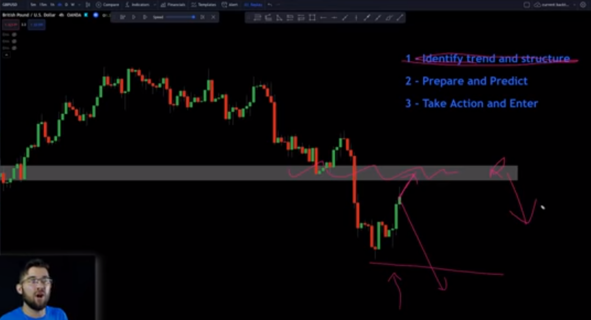
      - Take action and enter.
Drop down to the 1 hour chart for trading opportunities. Look for patterns like the double top or head and shoulders pattern.

Price action patterns Bearish “Double Top”. CEST.
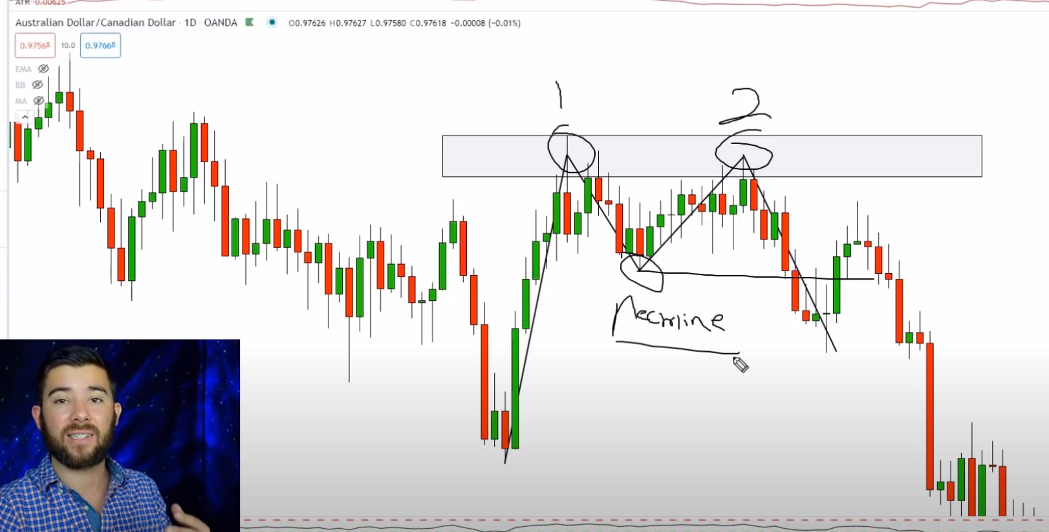

Conditions:
Steps 1: we're on the 4 hour chart.
      - Identify trends and structure (Structure = Latest level of support that was broken and tested multiple time in the past ).
      - Prepare and predict.
price can either go up or down, if price goes down we expect it to break below our current low why because we're in a downtrend,

If price goes higher, we expect the current level of structure support to become resistance and push the market lower why because it's the latest level of structure support that was broken and we know support often times becomes resistance it's also a level that's been tested multiple times there is our preparation and predicting.

If price goes up into the ZONE, my prediction is that we will continue lower based on the fact that i've identified my trend as a downtrend and that structure wise we are in an area that is likely to push the market lower.
Take action and enter.
Drop down to the 1 hour chart for trading opportunities. Look for patterns like the double top or head and shoulders pattern.

2. Wait for the market to break and close below that neckline and then getting a pull back into that neckline.
3. The support level created after top number one is known as our neckline. We need that neckline to break to validate that this is actually a double top.
Entry:
- Wait on a pullback after that break, we want to see a pull back into our level of support and that's where we're going to be placing possible trades and looking for the continuation down.
- Want to see a selling pressure which would be a red candle
Stop loss
- Stop loss would be above our swing high.
Price action patterns Bullish “Double bottom”. CEST.
Conditions:
Steps 1: we're on the 4 hour chart.
      - Identify trends and structure (Structure = Latest level of support that was broken and tested multiple time in the past ).
      - Prepare and predict.
price can either go up or down, if price goes down we expect it to break below our current low why because we're in a downtrend,

If price goes higher, we expect the current level of structure support to become resistance and push the market lower why because it's the latest level of structure support that was broken and we know support often times becomes resistance it's also a level that's been tested multiple times there is our preparation and predicting.

If price goes up into the ZONE, my prediction is that we will continue lower based on the fact that i've identified my trend as a downtrend and that structure wise we are in an area that is likely to push the market lower.
Take action and enter.
Drop down to the 1 hour chart for trading opportunities. Look for patterns like the double top or head and shoulders pattern.
Entry:
- Wait for the market to break and close above that neckline and then get a pull back into that neckline.
- For entry, wait for the market to pull back to that neckline once we pull back to the neckline, i want to see buying pressure that buying pressure is a green candle.
